What went well:

* Pair programming
* Deployment works
* Better burndown chart
* Less sprint ramp up time
* Acceptance criteria template was easier to follow

What we need to improve:

* More people reviewing pull requests
* Wording on user stories
* Feature documentation
* Keeping wiki up to date

What changes we are making:

* Check GitHub at least once a day, request reviewer
* Make sure whole team understands user story
* Require documentation when integration tests are implemented
* Update the wiki more frequently

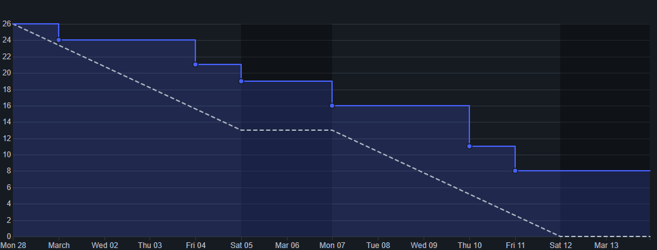The remaining points are all in the review process.